Test Case Result

When the user inputs the Student Password:
Valid data:
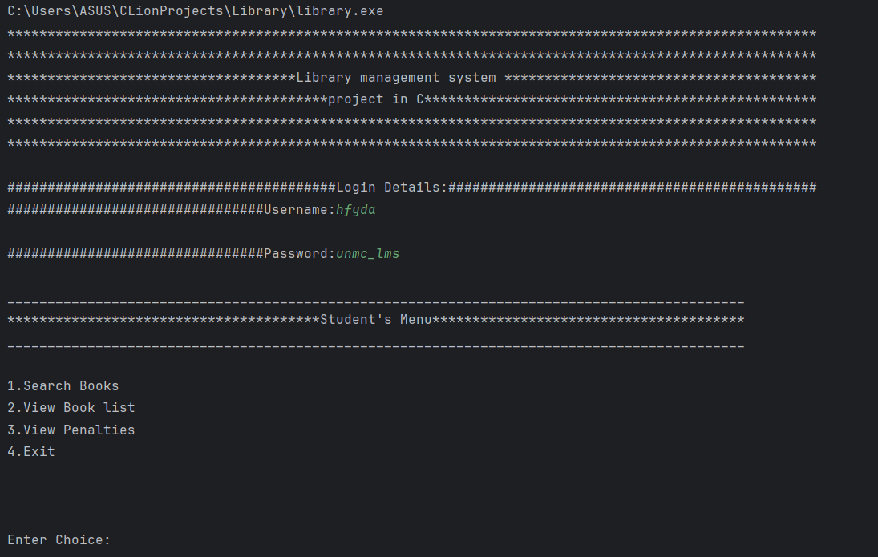
Invalid data:
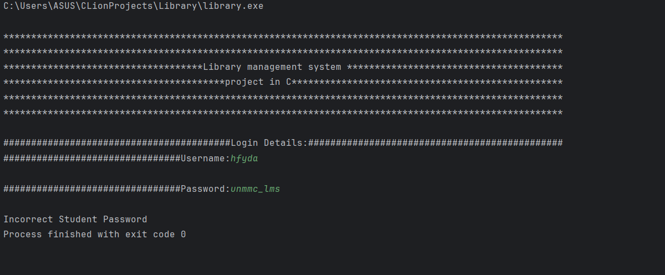

When the user inputs the Librarian Password:
Valid data:
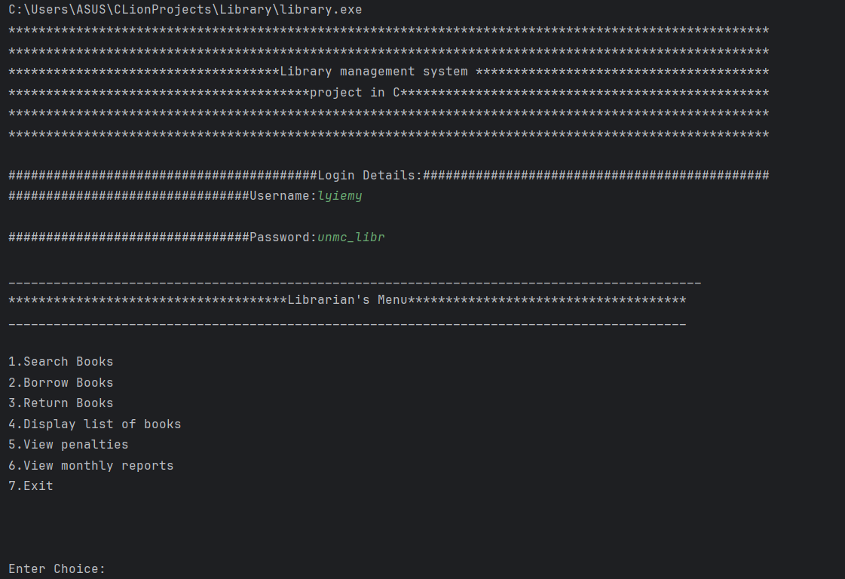

Invalid data:
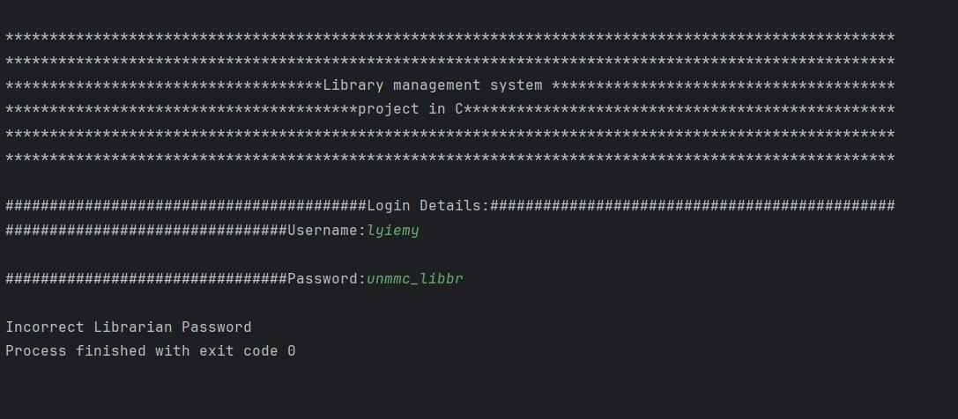

When the user inputs the Student’s Username:
Invalid data:

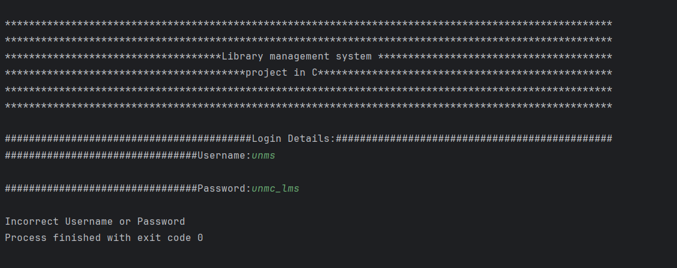

When the user inputs the Librarian username:
Invalid Data:

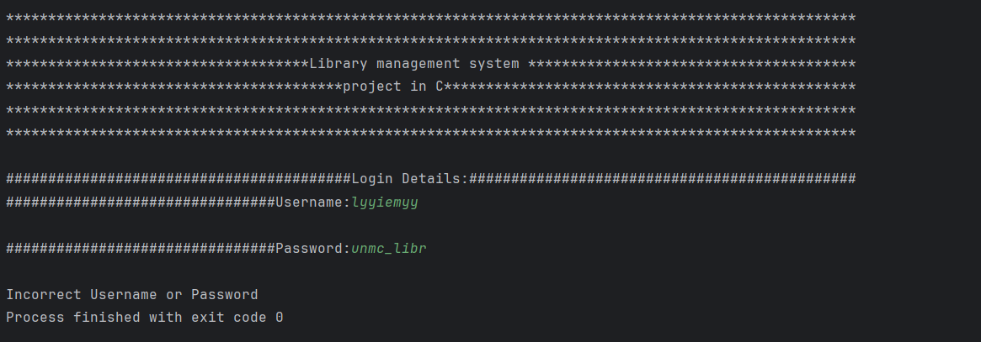

When the user inputs the choice for student Menu:
Valid Data:
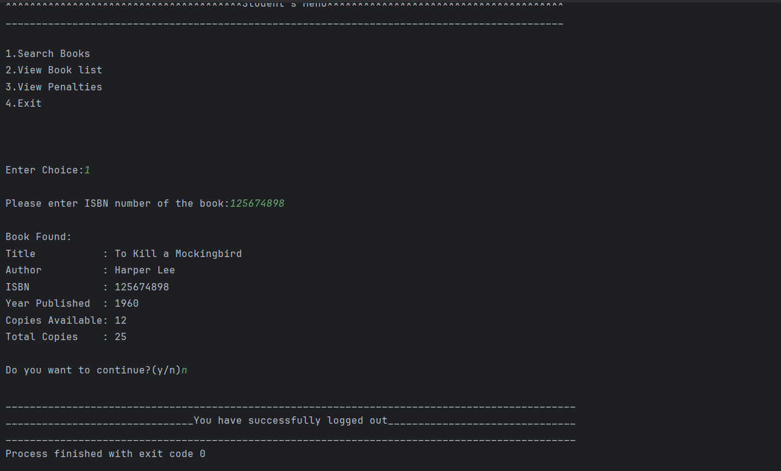
Invalid data:

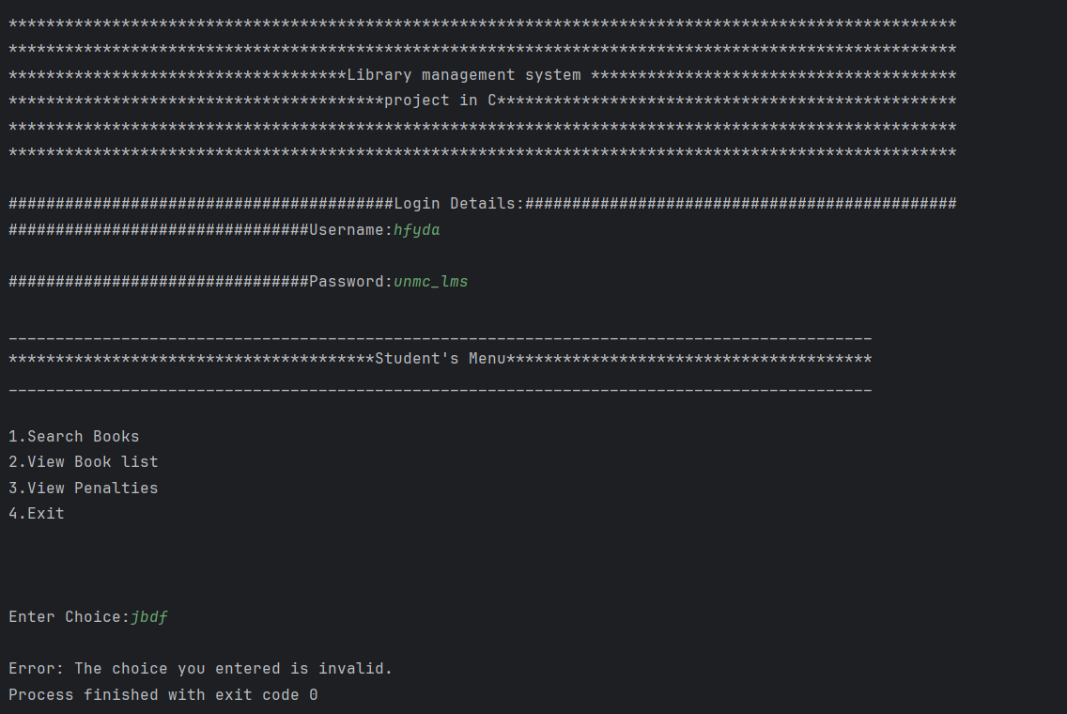

When the user inputs the choice for Librarian Menu:
Valid Data:
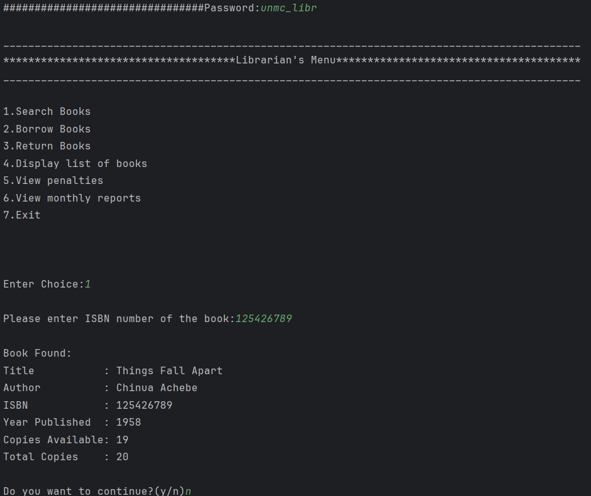

Invalid Data:
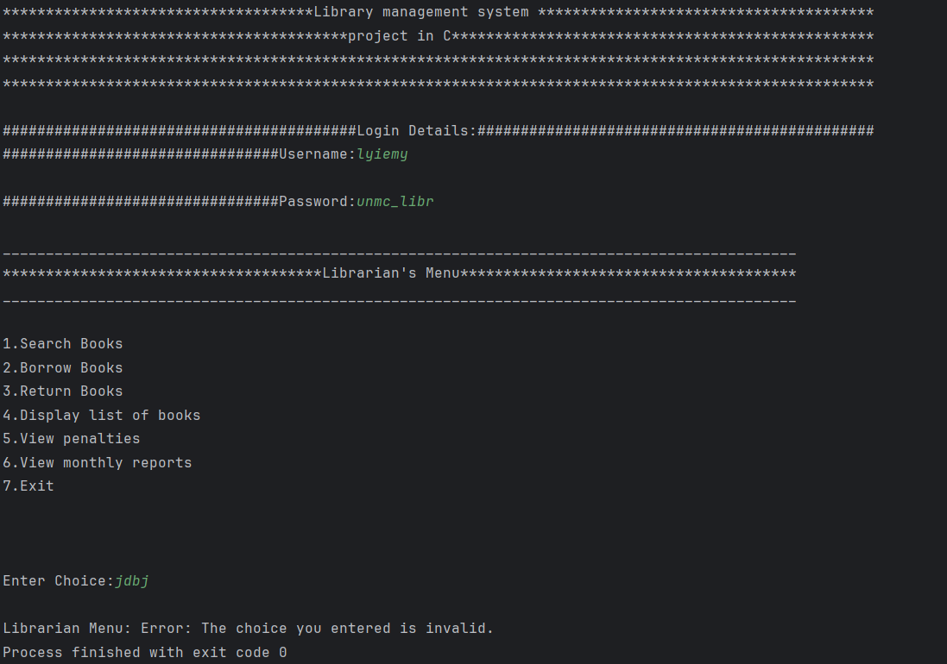

When the Student user enters a book ISBN number in the search book function:
Valid Data:
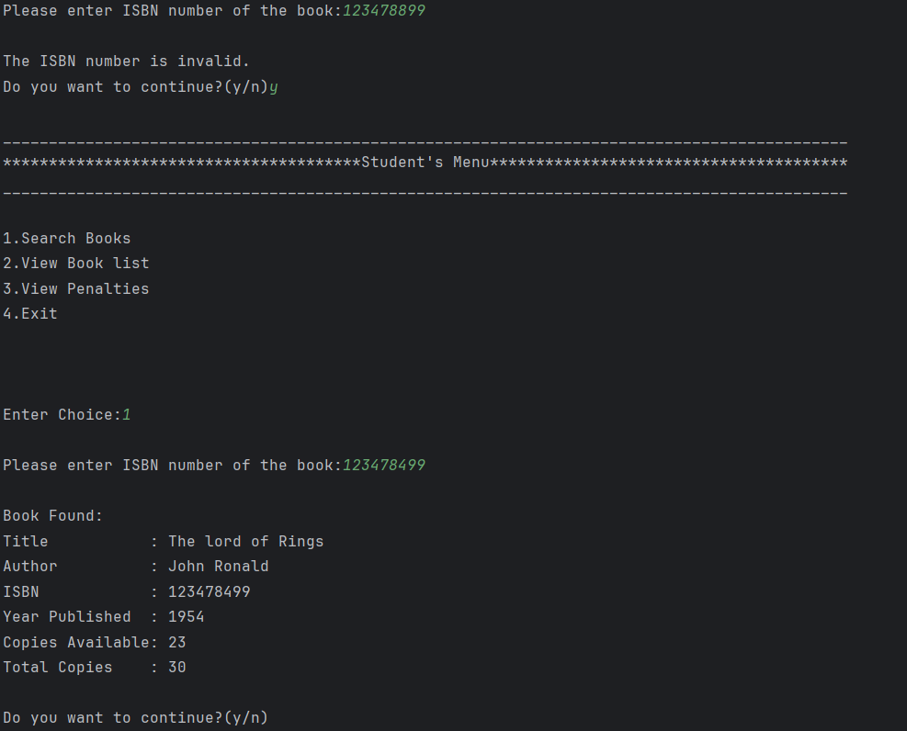

Invalid Data:
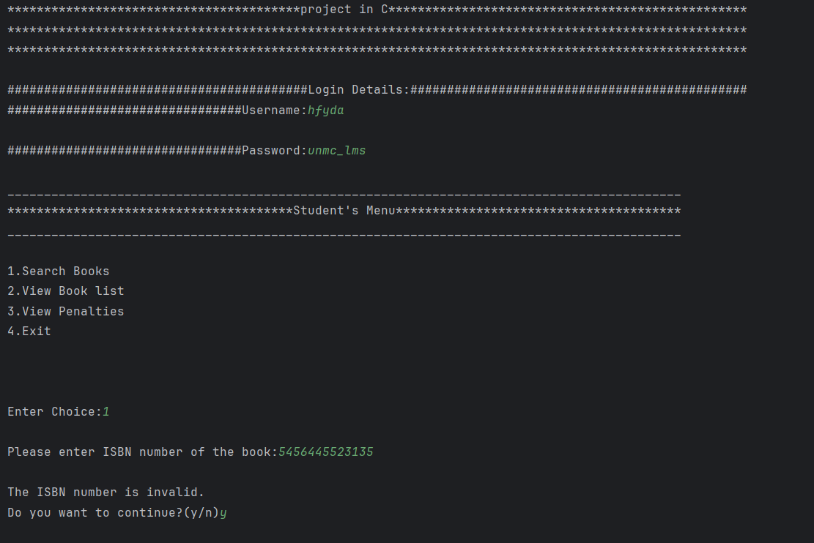

When the Student user inputs the student to display the penalty:
Valid Data:
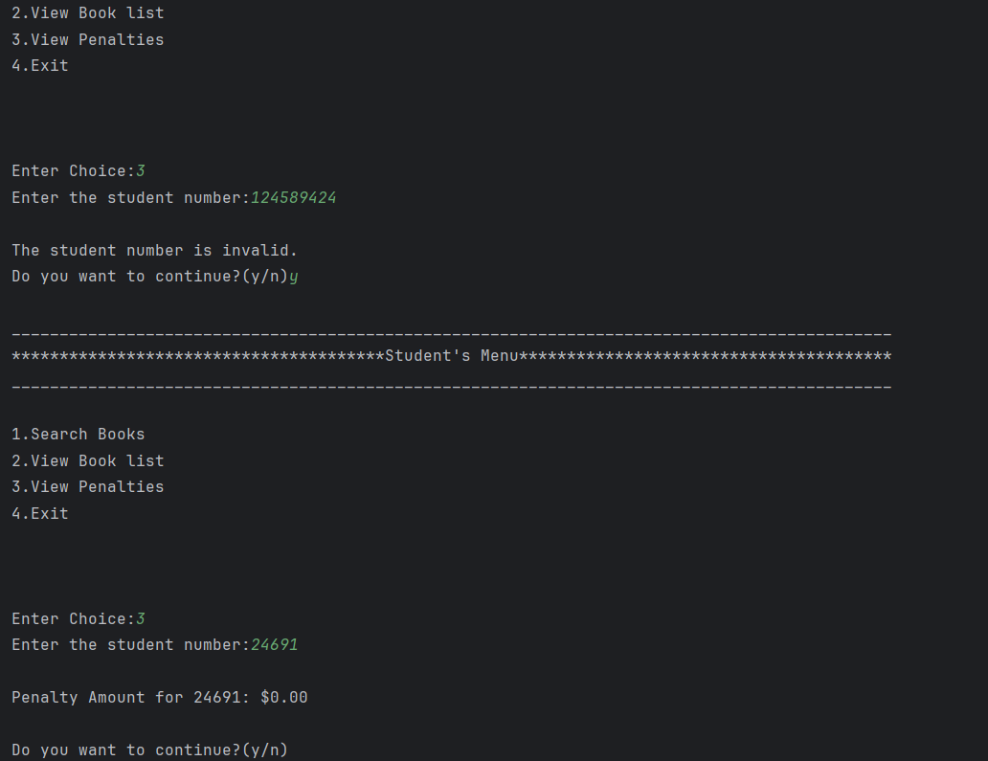

Invalid Data:
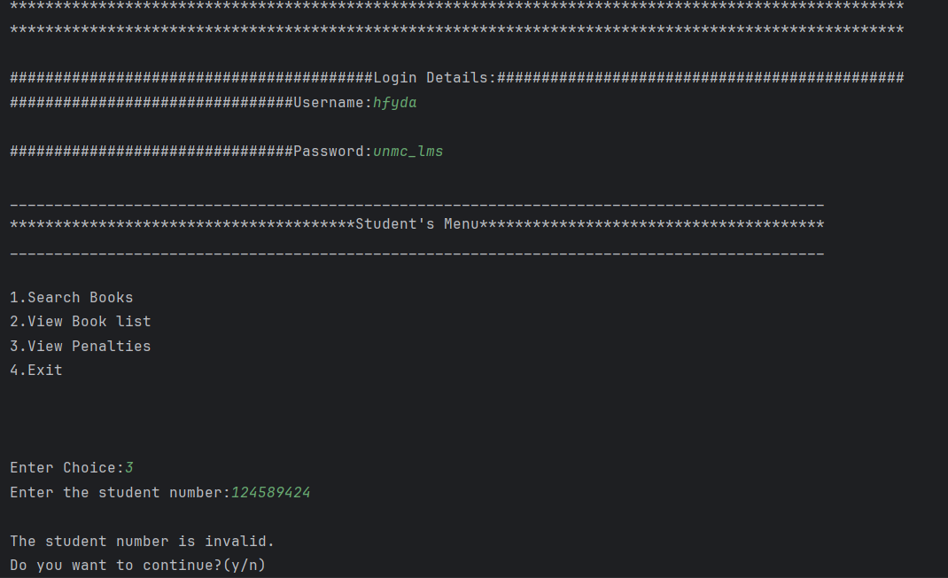

When the Librarian user inputs the ISBN number for the search book function:
Valid Data:

Invalid Data:
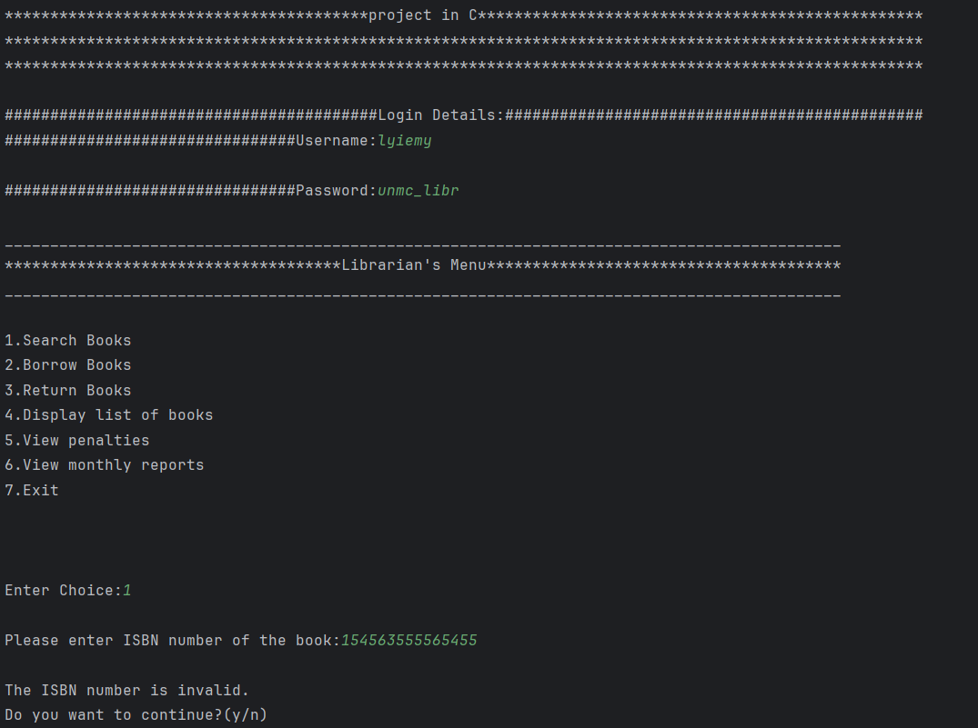

When the Librarian user inputs the borrow date for the student:
Valid Data:
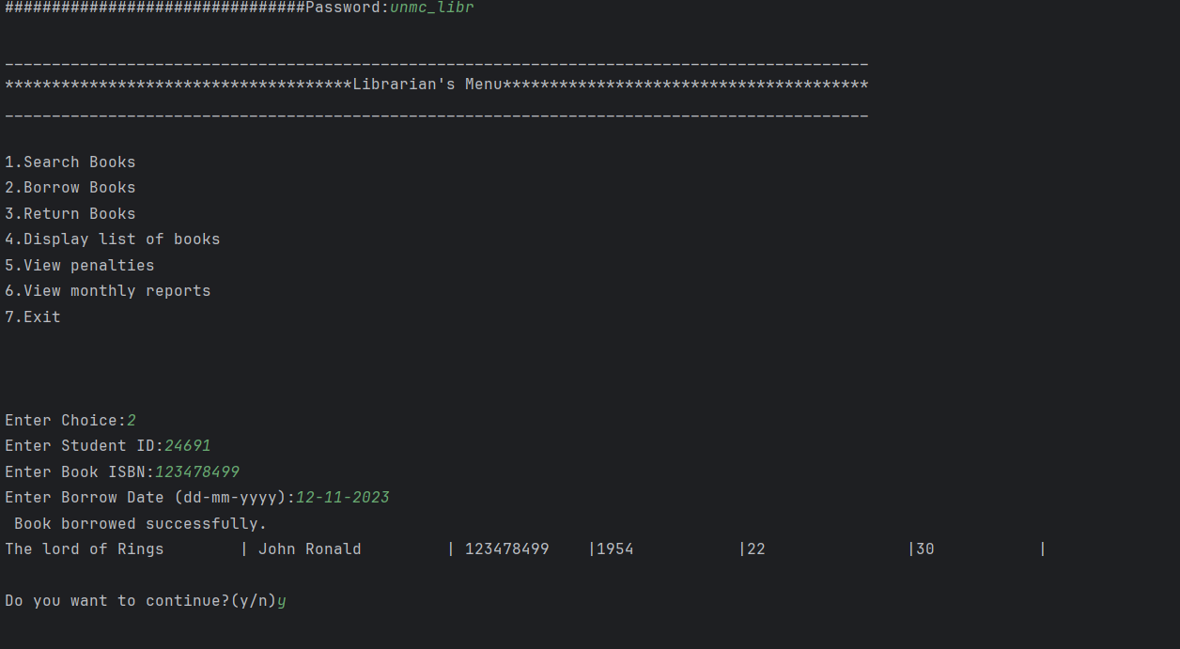
Invalid Data:
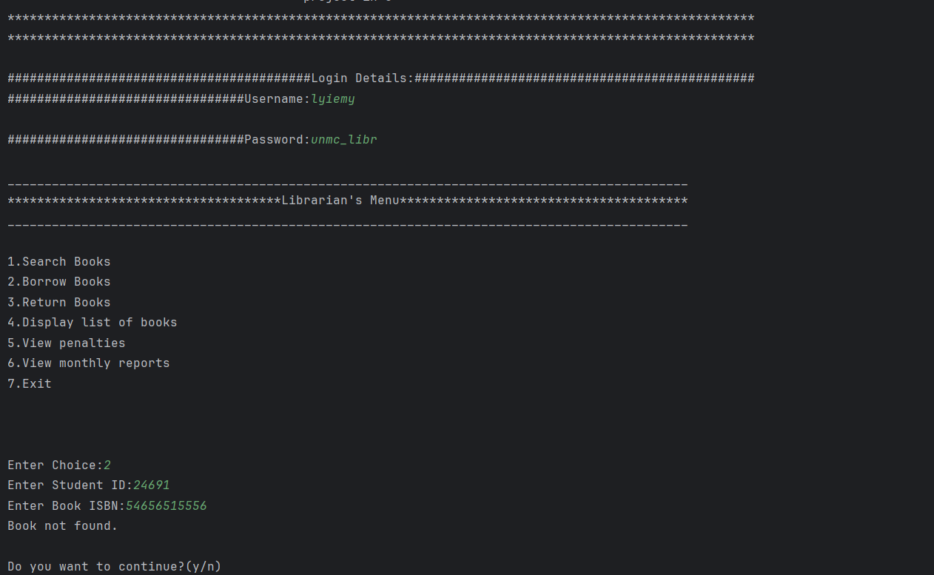
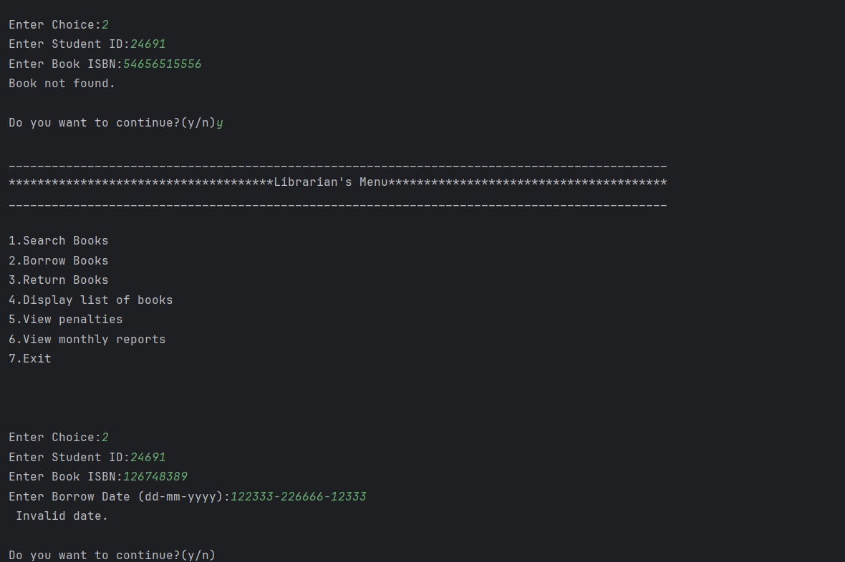
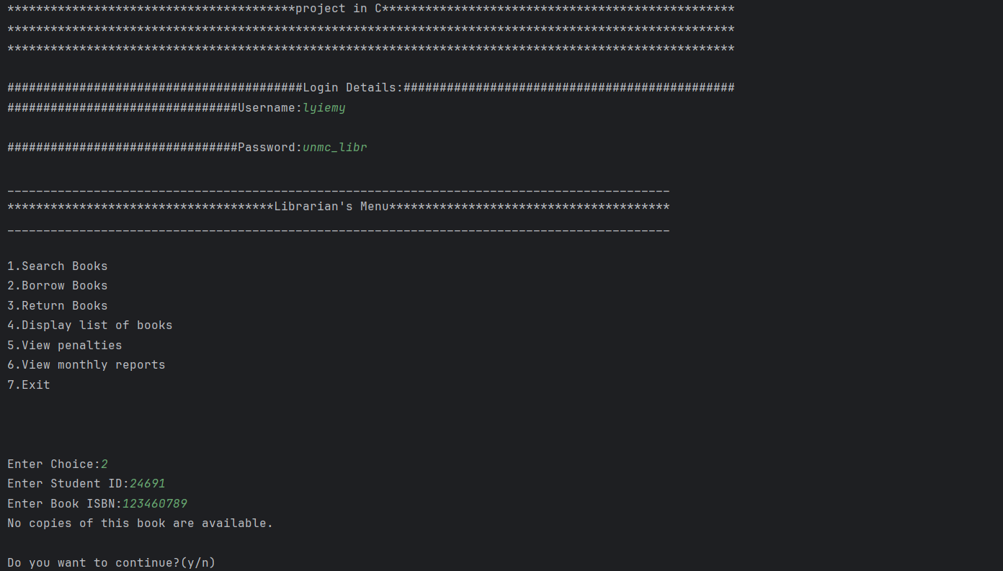

When the Librarian inputs a return date :
There are two cases:
- When the program checks if the book was borrowed by the student previously that is recorded in the bnrList.txt:
Valid Data:
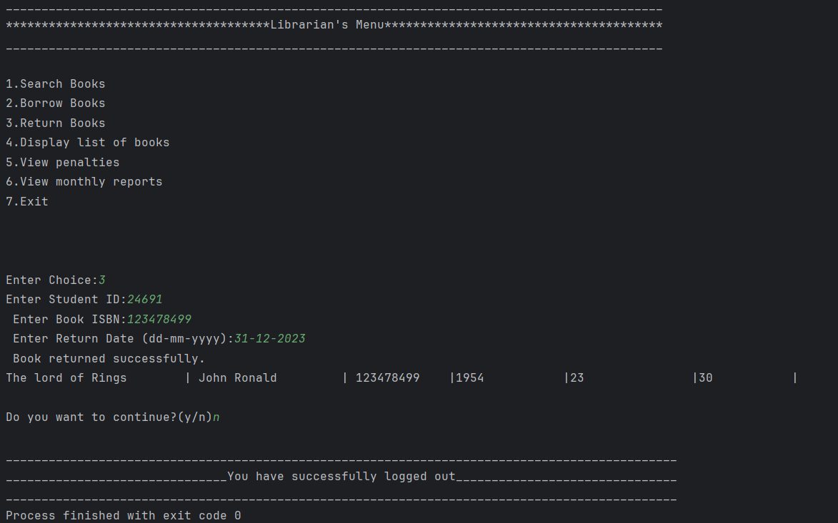

Invalid Data:
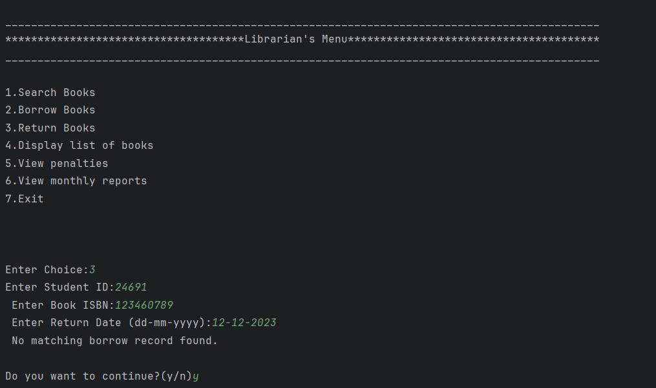

- When the librarian inputs the return date:
Valid data:


Invalid Data:
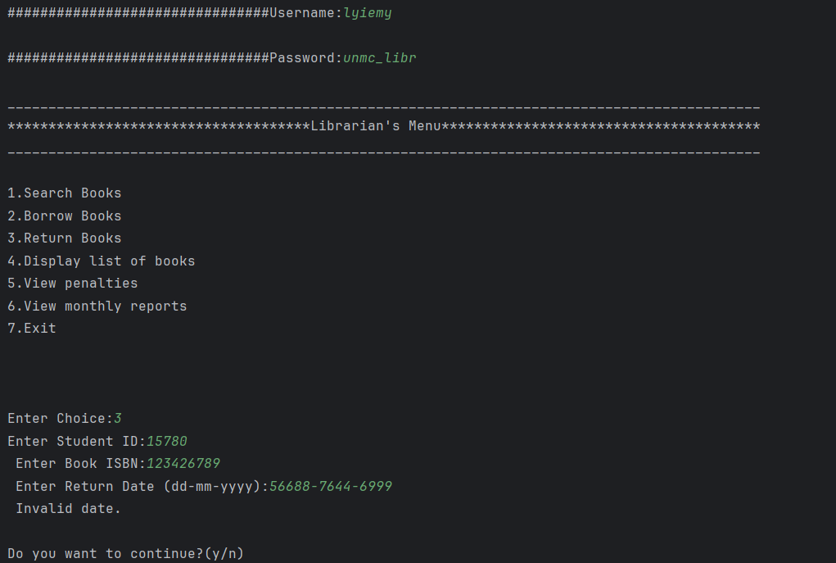

Additionally, there are three files updated in return book function:
So, one example is this:
Figure 1.0 below displays the book being borrowed and the book list information being updated by decreasing the available copies.
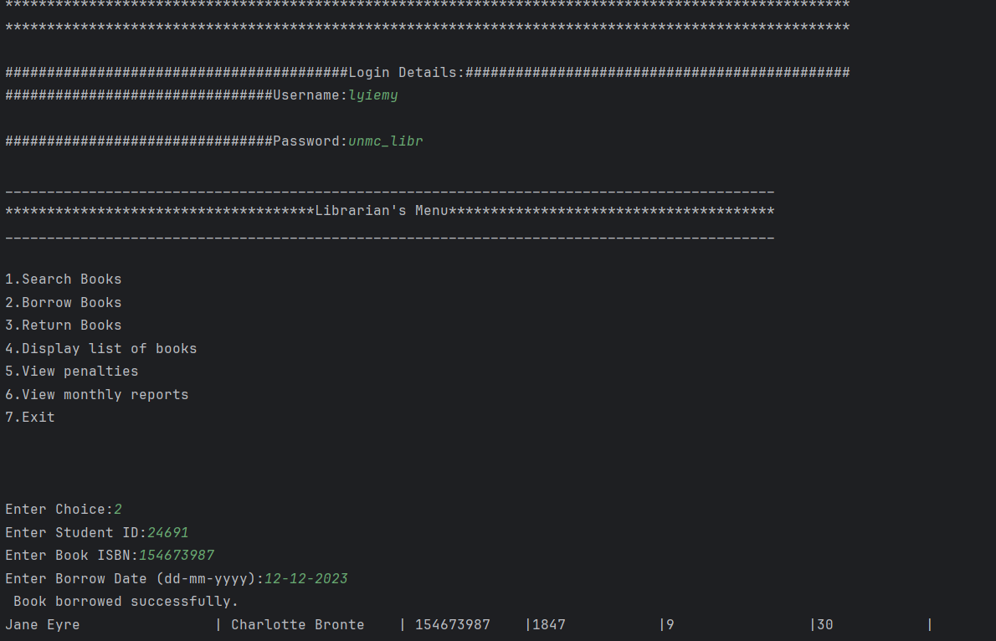
Figure 2.0 below shows the bnrList.txt saving and printing the data.
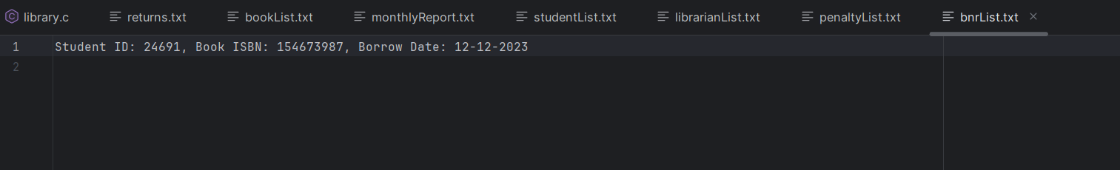

Figure 3.0 below displays the book being returned and the book information being update by incrementing the available copies. Also, when this function is done, behind the scenes the penaltyList.txt is updated.
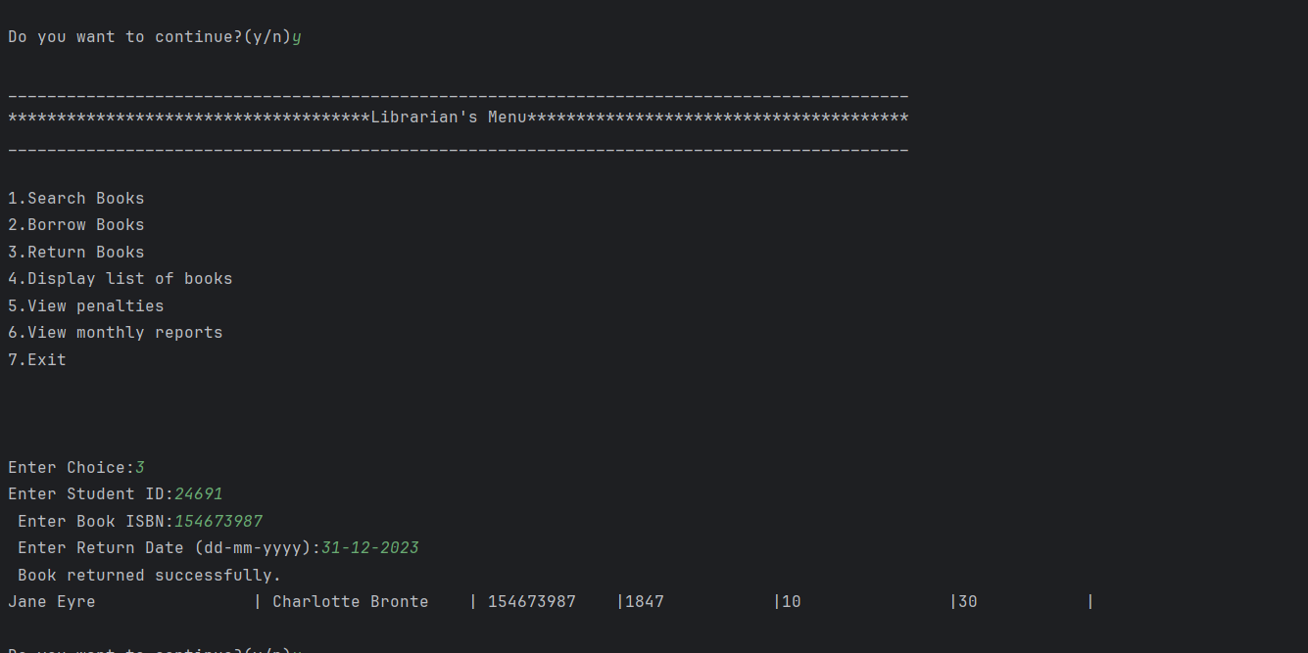
Figure 4.0 below when this function is done, the penaltyList.txt is updated.
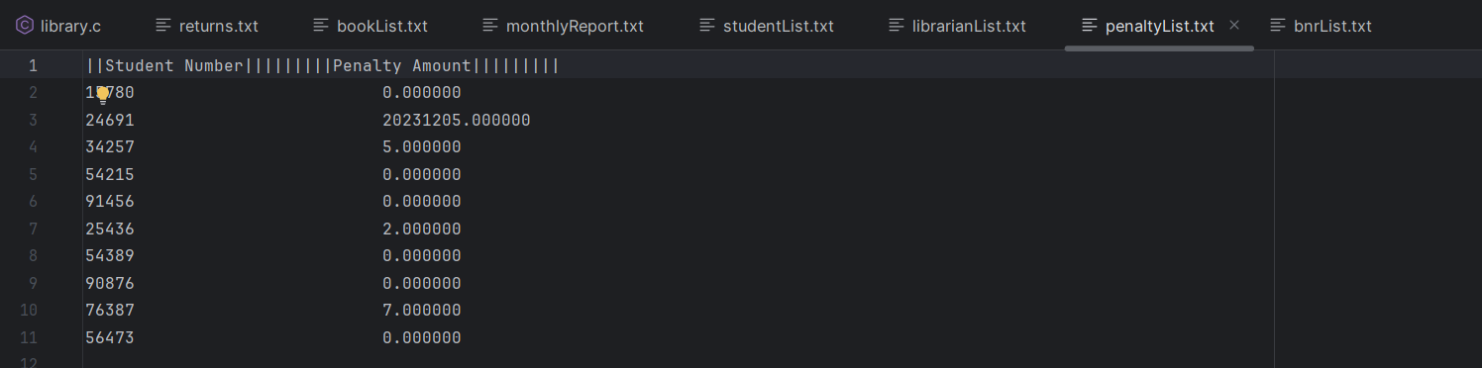

Figure 5.0 below shows the option of showing all the students’ penalties.
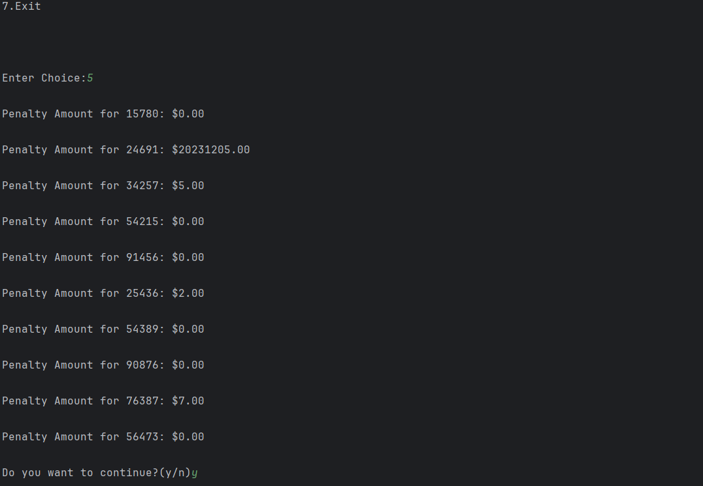
Figure 6.0 below shows the monthly report with the updated data.
